“Learner Demographics and Course Enrollment Behavior Analysis on EduPro”

INDEX
Sr. No. | Content | Page No.
 | Chapter 1: Project Overview | 1
1.1 | Project Title | 1
1.2 | Introduction | 1
1.3 | Objective | 1
1.4 | Stakeholder | 1
 | Chapter 2: Data Description | 2
2.1 | Data Description | 2
2.2 | Data Preprocessing | 2
 | Chapter 3: Methodology | 3 & 4
3.1 | tools and Technology Used | 3
3.2 | Analytical Approach | 3
 | Chapter 4: Visualization Results | 5 & 8
4.1 | Key Findings | 5
4.2 | Visualization Examples | 6
 | Chapter 5: Interface | 9 & 11
5.1 | Dashboard Features | 9
5.2 | KPIs | 10
5.3 | Design & Color | 11
 | Chapter 6 : Recommendation | 12
6.1 | Recommendation | 12
 | Chapter 7: Future Work | 13 & 14
7.1 | Future Improvements | 13 & 14
 | Chapter 8: Conclusion | 15
8.1 | Conclusion | 15
8.2 | Reference | 15

Chapter 1: Project Overview
  - Project Title
“Learner Demographics and Course Enrollment Behavior Analysis on EduPro”.
1.2. Introduction
- Analysing Edupro online learning platform data facilitates comprehension of demographic patterns, course popularity, and learner behaviour. In order to find trends in age groups, gender distribution, course categories, and course levels, this study examines learner enrolment data.
- The intention is to offer information that enhances educational planning and decision-making. This project creates an interactive dashboard with important metrics and visuals using Python and Streamlit.

1.3. Objective
The main objectives of this project are:
- To analyze learner enrollment data
- To identify popular courses
- To understand which age group is more involved in this learning platform
- To analyze gender participation
- To analyze learner pattern by creating visual dashboard

1.4 Stakeholder
- In order to understand enrollment trends and learner behaviour, this research uses data from education platforms to study student demographics and course preferences. The data reveals that course enrolments varied between genders and age groups, demonstrating that residents have a variety of learning demands.
- Strong interest in employability-focused education is indicated by the higher enrollment in some course categories, such as technical and professional skills. The value of fundamental learning programs is highlighted by the large enrolment in beginner-level courses.
- The interactive dashboard helps stakeholders successfully track trends in education by offering real-time information about enrolments by age, gender, category, and course level. Better resource allocation and training program planning may be facilitated by these findings.
- The results can support inclusive education activities and assist in identifying underserved student groups. Finding high-demand skill areas for workforce development can also be aided by the dashboard. All things considered, this project facilitates data-driven decision-making.

Chapter 2: Data Description
2.1. Dataset Description

The dataset contains information about the learner and their enrollments. There are 4 sheets in the file for student, Teacher, Course and Transaction with many columns but the important column which I have used are as follow:
Column Name | Description
UserID | Unique identification number assigned to each learner.
TeacherID | Unique identification number assigned to each Teacher.
CourseID | Unique identification number assigned to each Course.
TransactionID | Unique identification number assigned to each Transaction. This is the main column used to join the tables.
Age | Age of learners.
Gender | Gender of learners.
CourseName | Name of the course learner enrolled in.
CourseCategory | Category or field of the course (e.g., Data Science, AI, Web Development).
CourseType | Type of course such as Free or Paid
CourseLevel | Difficulty level of courses (Beginner, Intermediate, Advance)

2.2. Data Pre-processing
- Merging Data:
- In this Edupro online platform data there are 4 sheets such as User for student data, Teacher, Course and Transaction. For analysing and creation of dashboard this sheet needs to be combined.
- Each Sheet having unique Id to recognize each record uniquely. Transaction sheet is having all the unique ID of sheet like UserID, TeacherID, CourseID and TransactionID so This TransactionID column is used to merge all the sheets.
- Handling Missing values:
- To enhance data quality, missing values were found and eliminated from the dataset. Direct removing the missing value row is not a correct way to handle them as it increase loss of data.
instead of remove the missing value we can replace the missing value with the Arithmetic value (Mean,Median,Mode) Errors during analysis and visualization were avoided as a result .
- Cases are different to use the Arithematic values. If the column values are numerical we can replace missing values with mean or median and with mode for categorical values.

Chapter 3: Methodology

3.1. Tools and Technologies used
Excel : Excel is used to save the csv file after pre-processing.
Python: For this project, Python served as the primary programming language. helps in pre-process , analyse and creating dashboard.
Pandas: Pandas was used to analyze and manipulate data. Reading the dataset, cleaning the data, filtering records, and carrying out all tasks like classifying enrolments according to age group, gender.
Matplotlib: Bar charts and other simple graphs were made using Matplotlib. It aided in the visualization of the dataset's age distribution and course popularity.
Seaborn: Heatmaps and other sophisticated visualizations were made with Seaborn. It made it easier to display correlations between variables in a more aesthetically pleasing manner
Streamlit: The interactive dashboard was constructed using Streamlit. Users were able to apply filters such course level, category, age group, and gender. Additionally, it presented charts and KPIs in an interactive, structured manner.

3.2. Analytical Approach (EDA)
- Age Distribution analysis
- The distribution of learners across age groups is depicted in the age distribution chart.
The age range of 20 to 30 accounts for the majority of enrollments. This suggests that online education is more appealing to young adults.
- Older age groups participate at a relatively lower rate. This indicates that younger students are the primary users of online learning environments.

- Course Category Popularity
- The most popular courses are displayed in the course category chart. Enrollment in technical subjects like Finance and data science is increased.
- There is also consistent interest in professional courses like project management. Enrollment in some categories is lower than in others. This suggests that students favour classes that focus on career

- Gender Vs Course level
- The correlation between course level and gender is displayed in the heatmap. All course levels have both male and female students enrolled.
- The most enrolled students are in beginner-level courses. There are relatively fewer students in advanced courses. This implies that the majority of students are just getting started.

- Age Vs Course Category
- The link between age groups and course categories is displayed in the heatmap.
- Technical and skill-based courses are preferred by younger students.
- Professional courses are of interest to middle-aged groups. All age groups enjoy certain courses. This aids in understanding age-based learning preferences.

Chapter 4: Visualization Results

4.1. Key Findings

- Young Learner Dominate
- According to the age distribution data, most students are in the 20–30 age range. This suggests that the majority of users of online learning systems are young adults.
- The majority of people in this age group are either students or professionals in their early careers who want to advance their careers.
- Older age groups' lower participation rates raise the possibility that they lack the time or inclination to sign up for online courses.
- This observation emphasizes how younger audiences that are interested in career development find online learning platforms more appealing.
- By focusing on this demographic, course enrollment and engagement can rise dramatically.

- Technology Courses are Popular
- Technical courses like Data Science, Artificial Intelligence, and Machine Learning, Wed Development had the largest enrollments, according to the course category study.
- These courses are well-liked because they provide excellent career prospects and are highly sought after in the labour market.
- More and more students are selecting courses that help them develop useful, employable skills. Enrollments in non-technical courses are significantly lower, suggesting a trend toward education that emphasizes technology.
- The growing significance of digital skills in contemporary industries is reflected in this trend. The platform can gain by offering more technical courses.

- Beginner course have high demand
- Beginner-level courses have substantially higher enrollment than intermediate and advanced courses, according to the data. This implies that many students are unfamiliar with the disciplines and would rather begin with fundamental ideas.
- A wider audience can take beginner courses because they are frequently simpler to understand and require less prior knowledge. The decreased enrollment in advanced courses could be a sign that students become disinterested or find advanced subjects more difficult.
- Creating organized learning pathways for students ranging from novice to expert could aid in their retention. The significance of beginner-friendly material on the site is demonstrated by this observation.

- Balanced gender participation
- Both male and female students actively participate in online courses, according to the gender analysis. Both genders are interested in different course categories and levels, according to enrollment trends.
- There is no discernible gender difference in course enrollment, indicating equal access to educational options. This equilibrium shows that all people can access and use online learning tools.
- Males and girls have similar learning styles, as evidenced by their preference for beginner-level courses. Sustaining gender inclusion can contribute to ongoing enrollment growth and diversity.

4.2: Visualization charts
- First Chart
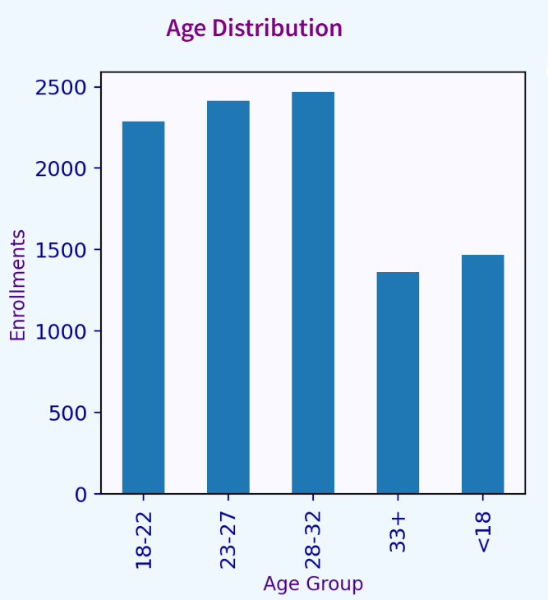

- A bar chart makes it simple to compare values between various groups. It makes it easier to see how many people are enrolled in each age group. Bar charts are perfect for categorical data, such as age groups
- Seeing which group has the most or lowest enrollments is made simple by them. They are therefore helpful for dashboards that analyze schooling.
- The number of enrollments for each age group is displayed in the chart. The majority of students are in the 28–32 age range, as evidenced by the greatest enrollment. Young adults are very interested.
- Compared to lower age groups, the 33+ age group has fewer enrollments. Although enrollments in the below-18 (<18) group are moderate, they are still lower than those in the major adult categories.
- Young people appear to be the platform's main user base, as the data shows that the majority of students are between the ages of 18 and 32.

- Second Chart
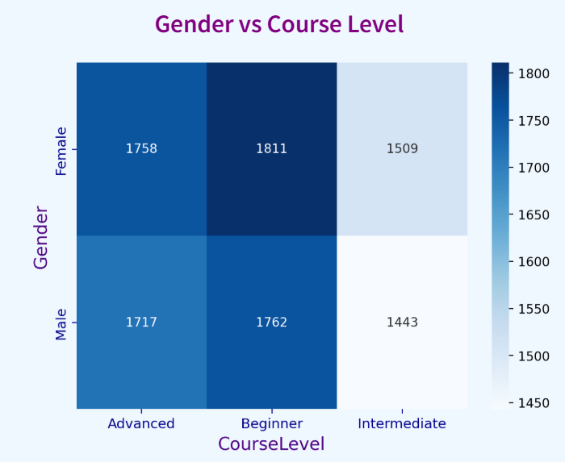

- Using colors, a heatmap illustrates the relationship between two groups. It make us understand value comparisons between rows and columns. Higher values are represented by darker hues, and lower values by lighter hues.
- Heatmaps make it easier to spot trends and patterns in data rapidly. When working with categorized data, such course levels and gender, they are helpful.
- The number of enrollments by gender across various course levels is displayed on the heatmap. Most students prefer beginning-level courses, as seen by the highest enrollment rates for both males and females in the Beginner level. In every course level, female enrollment is marginally higher than male enrollment. Although fewer people take Advanced level courses than Beginner level ones, participation is still high.
- For both genders, the Intermediate level had the fewest enrollments. The graph indicates that introductory classes are the most popular overall, with somewhat higher female participation than male participation.

- Third Chart
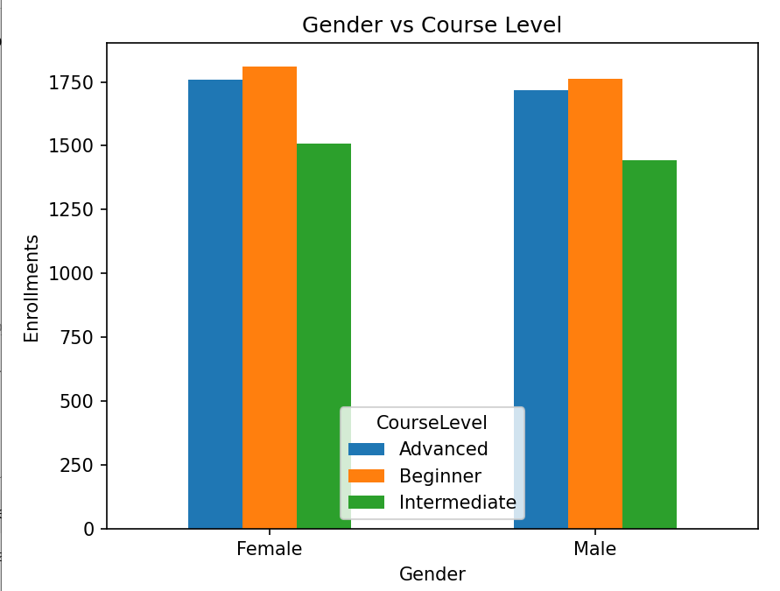

- When comparing several categories side by side, a grouped bar chart is utilized. It is simple to see the distinctions and similarities between categories with this kind of graphic. When comparing multiple variables in a single display, it is particularly helpful. The enrollment disparity between boys and females for each course level is evident here.
- Male and female enrollments for the three course levels beginner, intermediate, and advanced are displayed in the chart. The majority of students prefer to begin with basic courses, as seen by the basic level having the greatest enrollments for both genders.
- In every course level, female enrollment is marginally higher than male enrollment. The second-highest enrollment at the Advanced level indicates that many students continue on to higher-level courses. For both genders, the Intermediate level had the fewest enrollments.

Chapter 5: Interface

5.1.Dashboard Features
- Streamlit Dashboard
- An interactive platform for examining and analyzing learner data from the EduPro online learning system is offered by the Streamlit dashboard. Without having to read the raw tables, viewers may quickly grasp patterns and trends thanks to the data's visual presentation.
- At the top of the dashboard are Key Performance Indicators (KPIs), which provide a brief overview of crucial data including total enrollments and the most popular courses.
- Bar charts that display distributions like age-wise enrollments and course popularity are also included.
- Relationships like age group versus course category and gender versus course level are compared using heatmaps. The dashboard's design is tidy and well-organized.
- The dashboard is interactive and easy to use thanks to a sidebar that makes filters easily accessible. Instead of seeing static results, this enables visitors to dynamically explore the data.

- Filter option
- Users can tailor the analysis to their needs with the help of the dashboard's numerous filter choices. These filters enable users to concentrate on particular learner segments and make the dashboard interactive.
- Users can examine male and female learners' engagement individually by using the Gender filter. Understanding how various age groups use the platform and what courses they choose is made easier with the Age Group filter.
- Users can concentrate on particular subject areas, such web development or data science, by using the Course Category filter.
- Users can determine whether students prefer advanced, intermediate, or introductory classes by using the Course Level filter.
- Users can conduct more thorough analysis by combining these criteria, such as determining which gender enrolls in advanced courses more frequently or which age group likes a particular course type. Because of this, the dashboard is adaptable and helpful for more in-depth learner analysis.

5.2. KPIs
- Total Enrollment
- The total number of enrollments made by students on the platform is displayed by this KPI. It stands for the total amount of user activity and engagement.
- More students are actively enrolled in courses when there are more enrollments. This indicator aids in gauging the platform's use and popularity.
- Applying filters such as age group, gender, or category causes the value to change automatically.

- Course Category
- The course category with the most enrollments is displayed by this KPI. It aids in determining the subjects that students are most interested in.
- This knowledge is helpful in comprehending the developments in education nowadays.
With this knowledge, organizations can offer additional courses in well-liked categories.
Depending on the filters that are chosen, the value varies dynamically.

- Course Level
- The most popular course level among students is shown by this KPI.
- It assists in identifying if students favor advanced, intermediate, or introductory courses. This provides insight into the general proficiency level of platform users.
- It can assist in creating courses that are tailored to the needs of the students. When filters are applied, the metric is automatically updated.

- Age Group
- The age group with the most enrollments is displayed by this KPI.
- It assists in determining which age group uses the platform the most frequently. Programs for targeted learning can make use of this information.
- It also aids in comprehending the platform's demographic reach. Depending on the filters that are chosen, the value varies dynamically.

- Male Percentage
- The percentage of male students enrolled on the platform is displayed by this KPI.
- It facilitates comprehension of learners' gender engagement. One way to gauge inclusion is via this statistic.
- It sheds light on patterns of engagement based on gender. When filters are applied, the percentage automatically changes.

- Female Percentage
- The percentage of Female students enrolled on the platform is displayed by this KPI.
- It facilitates comprehension of learners' gender engagement.It sheds light on patterns of engagement based on gender.
- One way to gauge inclusion is via this statistic.When filters are applied, the percentage automatically changes.

5.3 Design & Color
- The information on the dashboard is easy to see and comprehend because to its clear and straightforward structure. To lessen eye strain and make the charts and KPIs easily readable, a light backdrop color is employed.
- To distinguish the filters from the main dashboard section, the sidebar is softly blue-highlighted. This makes it easier for consumers to see where they can interact with the data and apply filters.
- Indigo and purple hues are used in the primary headings and titles to make the dashboard look polished and unified. Bold colors are used to display KPI values so that crucial information may be quickly noticed.
- To make the most of the entire screen and eliminate extra blank space, the charts are arranged in a neat grid style. The dashboard looks polished and appealing thanks to the general color scheme of light blue, purple, and white.
- The dashboard doesn't appear crowded because the pieces are balanced in space. Simple and easy to understand font design. Users can quickly and clearly understand the insights because to the design.
- Eye strain is lessened because the color scheme is gentle and not overly vivid. Interactive filtering is supported by the general layout. The dashboard appears polished and easy to use thanks to its design.

Chapter 6: Recommendation
6.1 Recommendation
- Increase Beginner level courses
- The data reveals that learners are most enrolled in beginner-level courses. It is clear from this that a large number of users are either new to online learning or are just learning the fundamentals.
- To draw in new users, the platform should concentrate on introducing more courses that are suitable for beginners. There should be clear learning pathways available for both beginners and experts.This will help students maintain their interest and progressively advance their abilities. Overall enrollment can be greatly increased by adding more beginner-level content.

- Encourage Advance learning
- Enrollment in advanced courses is lower than that of beginner courses. This implies that students might not be carrying on with their education. From beginner to higher levels, the platform should offer defined learning pathways.
- Rewards and certificates might encourage students to finish advanced courses. Giving advice and suggestions might also assist students in selecting their next course.
- Promoting higher education will help users strengthen their skills.

- Target young Learners
- The majority of students are younger, particularly those in the 20–30 age range. Career advancement and skill improvement are very important to this group. Students and young professionals should be the target audience for marketing efforts.
- More students may be drawn in by offering special discounts or student-friendly initiatives. Younger audiences might be reached by promoting courses on social media channels. By concentrating on this demographic, platform engagement can rise.

- Increase Course Recommendation
- Different course preferences are displayed by different age groups and genders. Learner demographics should inform the recommendation of a personalized course. Students will find it easier to locate pertinent courses as a result.
- Recommendation systems can enhance user pleasure and experience. When classes align with students' interests, enrollment rates are higher. Enrollment rates can rise with better recommendations.
Chapter 7: Future Work

7.1. Future Improvement

- Adding More Data
- More learner records would improve the analysis's reliability and accuracy. More course categories and levels would make it easier to identify certain learner preferences. Including data from multiple years could increase the findings' relevance. Larger datasets may reveal more robust patterns and trends.
- As a result, the dashboard would be more useful for decision-making. Additionally, it would make it easier to spot shifts in student behavior over time. Better comparisons between various learner groups might be possible with more data.

- Adding Time Analysis
- Time analysis would make it easier to monitor changes in enrollment across various time periods, like months or years. It would enable the platform to recognize times of low activity and high enrollment.
- This could aid in the timely planning of marketing efforts. It would be easier to spot seasonal trends in learning behavior. Time patterns may indicate a rise or fall in interest in particular courses.
- This would make it easier to update or eliminate less well-liked courses. Additionally, it would assist in forecasting future demand for particular course categories.
- Trends in course popularity over time would aid in more effective resource allocation. The dashboard would be more helpful with time-based charts. Deeper understanding of learner engagement patterns would result from this.

- Adding Prediction
- Prediction models could be used to estimate future enrollments. Machine learning could be used to forecast popular courses ahead of time. Predictions could help with course material planning. It would improve the platform's decision-making.
- As a result, the project would become more intelligent and advanced. Which learner groups are most likely to enroll more could be determined with the use of predictions. Planning new courses depending on future demand would also be aided by it.

- Adding Course Recommendation system
- Recommendations may assist students in selecting classes according to their interests.
Age group choices could be used by the system to recommend courses.
Recommendations for courses may be derived from previously taken courses.
- Courses that are suitable for beginners could be suggested. More difficult courses could be recommended for advanced students. Suggestions might increase platform user engagement. It would make it easier for students to locate pertinent courses.
- Tailored recommendations would enhance the educational process. Enrollment in the platform's courses might rise as a result. The dashboard would become more dynamic and practical as a result.

Chapter 8: Conclusion
8.1. conclusion
- In order to comprehend enrollment trends and learner behavior, this project concentrated on evaluating learner data from the EduPro platform. To guarantee accurate results, the datasets were successfully combined, cleaned, and ready for analysis.
- Important patterns in gender participation, age distribution, and course choices across various levels and categories were identified by the analysis. In order to compile crucial information, such as total enrollments and popular courses, Key Performance Indicators (KPIs) were developed.
- To display the data in an understandable and intuitive manner, an interactive Streamlit dashboard was created. Users can quickly explore various learner groups and apply filters on the dashboard.
- Enhancing course offerings and raising platform learner engagement are two benefits of these findings. All things considered, the research shows how data analysis and visualization may help improve educational decision-making.

8.2 Reference
- The main source of data for analysis in this research was the dataset, which was made available on the project webpage.
- Google was used to find more references in order to comprehend the project specifications, data analysis methodologies, and visualization strategies.
- Learning how to use Python libraries like Pandas, Matplotlib, Seaborn, and Streamlit for data processing and dashboard development was made easier by online resources.
- In order to comprehend the basic ideas of data analysis, data cleansing, and visualization, degree textbooks and study materials were also consulted.
- These references made it possible to guarantee that the project was finished with accurate processes and appropriate analytical approaches.

